

CENTRAL EAST EDUCATION DIVISION

2026 MSCE MOCK EXAMINATION
BIOLOGY
Tuesday, 17 March Subject Number: M022/I
Time Allowed: 2 hours
08:00 – 10:00 am
PAPER I
(100 marks)
Instructions

- This paper contains 13 printed pages. Please Check.

- Write your name at the top of each page of this question paper.

- This paper has two sections, A and B. Answer all the questions in both sections in the spaces provided.

- The maximum number of marks for each answer is indicated against each question.

- In the table provided on this page, tick against the question number you have answered.

- At the end of the examination, hand in your paper to the invigilator when time is called to stop writing.
Question Number | Tick if answered | Do not write in these columns
1
2
3
4
5
6
7
8
9
10
11
12
13
Total

Section A (70 marks)
Answer all the questions in this section in the spaces provided
- a. Explain the meaning of the term compensation point in photosynthesis.
________________________________________________________________________________________________________________________________
(1 mark)
b. Describe any two adaptations of a leaf to its function.
________________________________________________________________________________________________________________________________________________________________________________________________________________________________________________________________________
(4 marks)
c. Describe any two adaptations of ileum to its function.
__________________________________________________________________ __________________________________________________________________ __________________________________________________________________ __________________________________________________________________ __________________________________________________________________
(4 marks)
2. a. State the significance of adding heparin to the blood withdrawn from the
body into the dialyser during dialysis process.
__________________________________________________________________ (1 mark)

b. State any one similarity between the dialysis tubing and the tubules of the
nephron.
_________________________________________________________________ (1 mark)

c. Why are there many smaller channels in the dialysis machine rather than one larger tubing?
____________________________________________________________________________________________________________________________
- marks)
d. Explain any two adaptations of proximal convoluted tubule of the nephron for selective re-absorption of essential substances.
________________________________________________________________________________________________________________________________________________________________________________________________________________________________________________________ (4 marks)
e. Explain any two functions of placenta in human beings.
________________________________________________________________________________________________________________________________________________________________________________________________________________________________________________________________(4 marks)

- Figure 1 is a diagram showing part of a root hair and its associated cells.
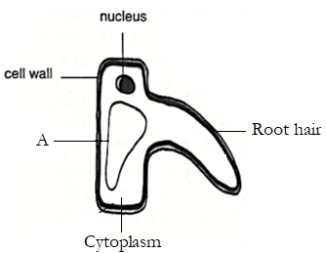

a. Name the part marked A.
_______________________________________________________________ (1mark)
b. Explain any one adaptations of root hairs to their function.
________________________________________________________________________________________________________________________________ (2 marks)
c. Give any one function of the cerebrum.
________________________________________________________________________________________________________________________________ (1 mark)

d. Explain any one function of cerebral-spinal fluid.
____________________________________________________________________________________________________________________________________
- Marks)
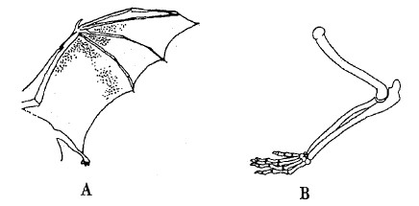
- Figure 2 is a diagram showing the wing of a bat and the leg of a lizard.
a. What name is given to these structures?
__________________________________________________________________ (1 mark)
b. Explain how the structures in figure 2 above support the theory of organic evolution.
____________________________________________________________________________________________________________________________________ (2 marks)
c. Explain how natural selection causes speciation.
.
____________________________________________________________________________________________________________________________________ (2 marks)

- a. Define a hormone.
__________________________________________________________________________________________________________________________
(1 mark)
b. Mention any one function of the following hormones in a human being.
i. Follicle stimulating hormone
_______________________________________________________________________________________________________________________________________________________________________________________
(1 mark)
ii. progesterone
_______________________________________________________________________________________________________________________________________________________________________________________
(1 mark)
c. Explain any one abnormal conditions associated with the human reproductive system.
________________________________________________________________________________________________________________________________________________________________________________________________
(2 marks)
d. Give a reason why only one sperm fertilizes the ovum.
________________________________________________________________________________________________________________________________ (1 mark)

- a. A child developed high fever, cough, red eyes and itchless rashes on
the face which then spread to the rest of the body.
(i). Identify the disease the child was suffering from.
_________________________________________________________________ (1 mark)

(i). Name the causative agent of the disease.
__________________________________________________________________ (1 mark)

b. State the mode of transmission of the disease.
__________________________________________________________________ (1 mark)
c. State any two ways of preventing and controlling the disease.
____________________________________________________________________________________________________________________________________
(2 marks)
d. Define the term organ transplant.
__________________________________________________________________ (1 mark)
e. Name any two organs that can be transplanted.
____________________________________________________________________________________________________________________________________
- marks)
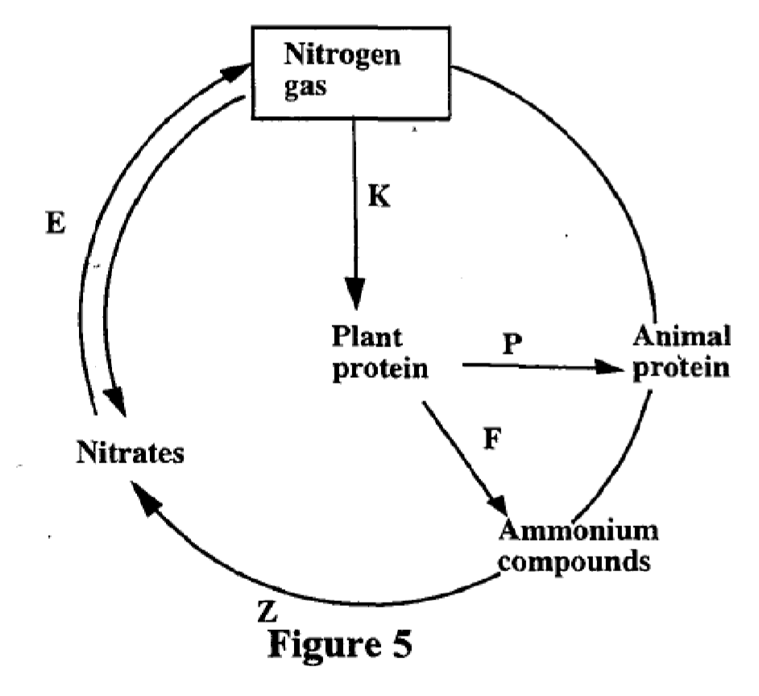
- Figure 3 is a diagram showing a nutrient cycle in nature.

- Name the processes taking place at P and Z.
P: __________________________________________________ (1 mark)

Z: ___________________________________________________(1 mark)
- Explain how the process at K takes place.
_________________________________________________________________________________________________________________________________________________________________________________________________________________________________________________________________________________________________________________ (4 marks).
- Figure 4 is a diagram showing a process taking place in the human body.

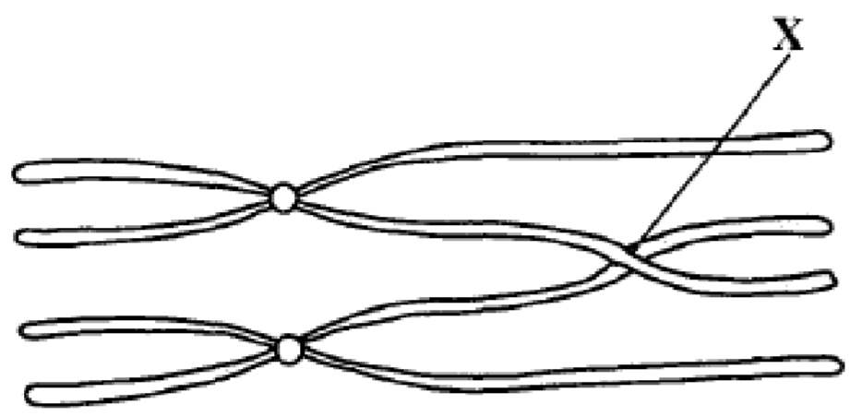
Figure 5
a(i). Identify the process taking place in the figure above.
________________________________________________________(1 mark)
(ii). State two organs in the human body where the process mentioned in 8a (i)
above takes place.
____________________________________________________________________________________________________________________________________
(2 marks)
b(i). Name the part marked X.
___________________________________________________________(1 mark)

(ii). Explain the importance of the process taking place at X.
____________________________________________________________________________________________________________________________________
(2 marks)
- a. State any two abnormal conditions associated with the human respiratory system.
________________________________________________________________________________________________________________________________
(2 marks)
b. Explain any two adaptations of the respiratory structures in human beings. ________________________________________________________________________________________________________________________________________________________________________________________________________________________________________________________________________
(4 marks)
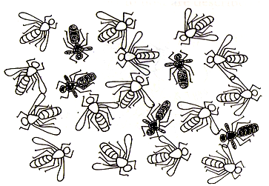
- Figure 5 is a diagram showing off springs of fruit flies produced after mating a black fruit fly and a white fruit fly. Use T for a dominant gene and t for a recessive gene.

(a). Write the two probable genotypes of the parents.
________________________________________________________________________________________________________________________________(2 marks)
b. Write down the probable genotypic ratio of the offspring.
_____________________________________________________ (1 marks)
c. State any two principles of Mendelian genetics.
__________________________________________________________________________________________________________________________
(2 marks)
d. Mention any one limitation of fossil records as one of evidences for organic evolution.
__________________________________________________________________________________________________________________________
(1 mark)

Section B (30 marks)
Answer all the three questions in this section in the spaces provided. Your answers should be in an essay form.
- Describe Darwinian theory of evolution by natural selection.
__________________________________________________________________________________________________________________________________________________________________________________________________________________________________________________________________________________________________________________________________________________________________________________________________________________________________________________________________________________________________________________________________________________________________________________________________________________________________________________________________________________________________________________________________________________________________________________________________________________________________________________________________________________________________________________________________________________________________________________________________________________________________________________________________________________________________________________________________________________________________________________________________________________________________________________________________________________________________________________________________________________________________________________________________________________________________________
(10 marks)
- Describe how urine is formed in the body of human being.
__________________________________________________________________________________________________________________________________________________________________________________________________________________________________________________________________________________________________________________________________________________________________________________________________________________________________________________________________________________________________________________________________________________________________________________________________________________________________________________________________________________________________________________________________________________________________________________________________________________________________________________________________________________________________________________________________________________________________________________________________________________________________________________________________________________________________________________________________________________________________________________________________________________________________________________________________________________________________________________________________________________________________________________________________________________________________________
______________________________________________________________________________________________________________________________________________________________________________________________________ (10 marks)

- Explain any five ways of preventing malaria in the communities.
__________________________________________________________________________________________________________________________________________________________________________________________________________________________________________________________________________________________________________________________________________________________________________________________________________________________________________________________________________________________________________________________________________________________________________________________________________________________________________________________________________________________________________________________________________________________________________________________________________________________________________________________________________________________________________________________________________________________________________________________________________________________________________________________________________________________________________________________________________________________________________________________________________________________________________________________________________________________________________________________________________________________________________________________________________________________________________
(10 marks)
END OF QUESTION PAPER
NB: This paper contains 13 Printed pages.

